Setting up Phone or in person appointments:
Tax preparation appt:
Most of the prepares will advised on their preferred method for scheduling tax preparation appointments.
*All clients MUST have their tax documents to the office 5 DAYS prior to the appt.
If the client has not provided tax documents 5 days prior to the appointment, they will need to reschedule the appointment.
*Confirm with Prepare if their meetings are to be 1 hour or 30min.
*Open Outlook
*Go to Calendar (bottom left of the window, calendar icon)
*Select Staff member’s shared calendar: 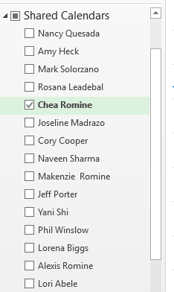
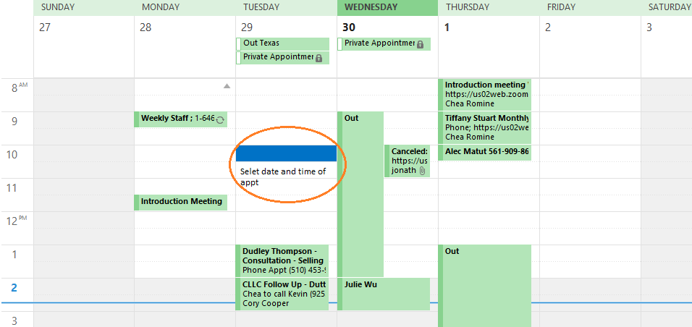
If Emailing appt info, select: Invite Attendees,
Input client(s) email
Subject line: Tax preparation appt with Client Name
Location: (If phone appt: Best contact number that has been confirmed with client)
(If in person, “conference room”)
If Zoom tax appt, see “Setting up Zoom appt” instructions, be sure to note the appt memo of documents requested prior to the appt, and if they have been submitted.
Edit notes prior to sending, no internal information should be sent to the client.
If needed, add a second appt with client name and title “Meeting Notes”
- Put in any internal notes regarding the meeting,
  - This will show double booked but with the same client name.
Initial/name appt notes.
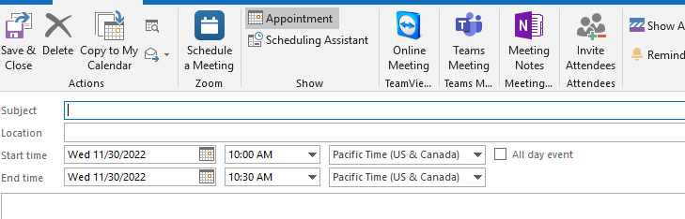

Call in Phone appointment:
- For clients that call in and want to speck with Amy or Chea
  - Confirm what they are calling about: tax returns, bookkeeping, sales tax, tax planning, any general tax questions
Schedule these appointments 2 DAYS OUT, if client calls in on Monday, the earliest scheduled time would Wednesday.
*If client called in with urgent matter, Teams Preparer to see if available to take the call *
* If Client is calling with compliant of services, Teams Amy and Chea to advised, and Teams Ryan or Lorena to assist*
Call-in phone appt are 30min. in length
Select New appointment

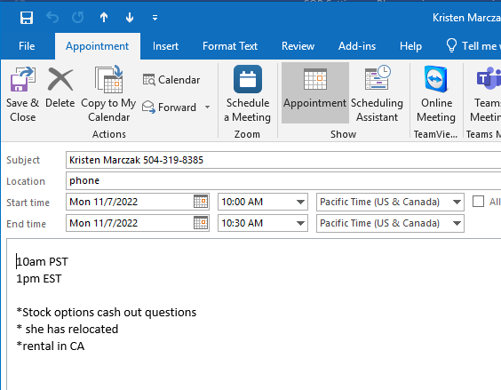
Subject: Tax appt with client name (Introduction Meeting Client name )

Location: Client to call in
Select time and date (if for Amy and Chea include PST and EST)
Notes: include notes of the client’s questions/ concerns in the memo section of the appt.
Client contact number in case the call is disconnected.
Initial notes.

New client introduction meeting with Chea and Amy:
Set up Zoom Appt for all new Introduction meetings with Chea or Amy
Length of meeting should be 1 hour
- In the appt, add referral agent ( IE Dustin Wylie, David Fisher)
(see Setting up Zoom appointment SOP )
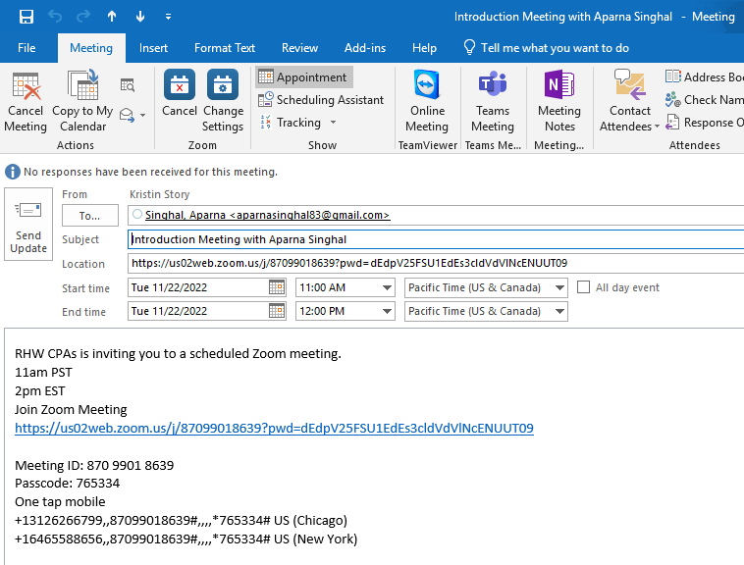

Monthly Meetings with clients
In November or December, contact clients that have monthly meetings with Chea.
Confirm if they prefer Zoom or phone meetings.
Sched monthly meetings per quarter ( Jan-March:Quarter1 , April -June, Quarter 2, July – September Quarter 3, October- December, Quarter 4)
Email client, if no response within 48/72 hours follow up with a call
Schedule monthly meetings in the mornings during the second or third week of the month.
This will allow sufficient time to complete the bookkeeping and review.
Label appt : January Monthly meeting :Tiffany Stuart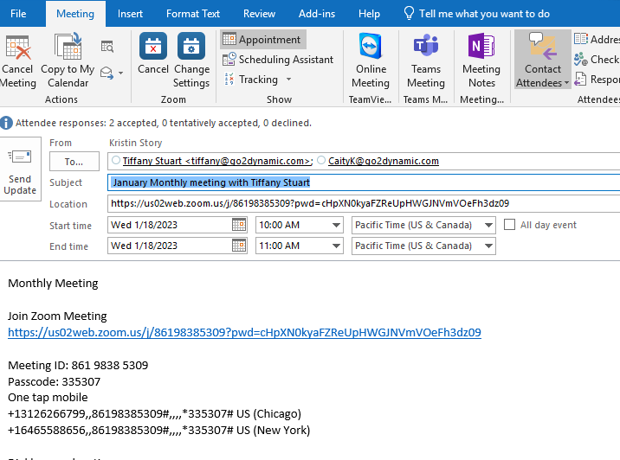

Rescheduling appointments
When rescheduling appt.
Contact client of need to reschedule with open dates for rescheduling.
Note the appt with date and time and how client was contacted.
EX: 3/5/22 LVM for John Smith to resched appt-KMS
4/20/22 S/W john Smith to rescehd appt from 3/5/22 -KMS

